Berwick and District
Tennis Association
Inc. A0009310N
(Founded 1984)

BY-LAWS
Summer 2018-9
(Revised Sep 2018)

CONTENTS

POLICY STATEMENT 3
AUTOMATIC FINES 4
BY-LAWS 5
ANNUAL GENERAL MEETINGS 5
RULES FOR HOME AND AWAY MATCHES AND FINALS 5
President’s Shield 5
Singles/Doubles 6
Doubles 7
AFFILIATION 8
FEES 8
QUALIFICATION AND REGISTRATION OF PLAYERS 8
MATCH COMMITTEE 9
CONDUCT OF MATCHES 9
COURT / WEATHER CONDITIONS 10
SUBSTITUTES DURING A MATCH 10
BALLS 11
POINTS SCORING / RESULT REPORTING 11
FORFEITS 12
DISPUTES 12
PROTESTS 12
PLAYER OR OFFICIAL CONDUCT 13
FINAL SERIES 13
PENNANTS AND TROPHIES 14
CLUB FINES 14
TENNIS LAWS 14
HONORARIUMS 14
MATTERS NOT COVERED 14
CODE OF DRESS 15
TENNIS ETIQUETTE 16
CODES OF CONDUCT 17
TIE-BREAK PROCEDURE 18
BDTA CONTACTS 19
CLUB DIRECTORY 19
NOTES ON THE USE OF OTHER THAN 4 TEAM MEMBERS 22
Doubles Only Sections 22
Singles/Doubles Sections 28

POLICY STATEMENT

The Berwick and District Tennis Association (BDTA) is an inclusive association that welcomes and encourages children of all abilities to play tennis. Children with a diagnosed intellectual or physical disability will be allowed appropriate assistance, to help them play and score their matches. The BDTA Executive will work with parents and clubs on an individual basis to give children with disabilities every opportunity to enjoy playing tennis in the BDTA junior competition.

The BDTA requires all member clubs to be directly affiliated with Tennis Victoria (By-law 3). In line with Tennis Victoria policy, all clubs are to develop and keep a set of Safeguarding Children Guidelines which are publicised at the club and regularly viewed by committee members, coaches, junior team managers and parents.

It is strongly advised that all club committee members and junior team managers have a Working with Children Check, with a copy kept on file and updated regularly as roles change. All coaches must have a Working with Children Check card.

Note: The Pakenham Tennis Club has already prepared a set of Guidelines For Working With Children which could be used as a model for your club’s version. A copy can be found at www.bdta.com.au/downloads/.

AUTOMATIC FINES
TEAM FORFEIT (Other than President’s Shield) $40.00
TEAM FORFEIT (President’s Shield) $20.00

The 3rd forfeit by a team will attract the additional penalty
of elimination for the remainder of the season.

TEAM WITHDRAWAL AFTER THE DRAW IS FINALISED $50.00

FAILURE TO REPORT RESULTS BY ON-LINE DEADLINE $20.00

FAILURE TO PROVIDE TIMELY ADVICE TO VISITING
TEAMS OF THE USE OF AN ALTERNATE VENUE
SECOND AND SUBSEQUENT OFFENCES $10.00

FRIVOLOUS PROTEST $ 5.00

FAILURE TO SUPPLY AN ADULT UMPIRE (Doubles Sections) $20.00

FAILURE TO PROVIDE THE APPROPRIATE
NUMBER OF ADULTS FOR A MATCH $20.00

FAILURE OF A CLUB DELEGATE TO ATTEND
(a) GENERAL MEETING $10.00
(b) ANNUAL GENERAL MEETING $50.00
This fine will be imposed with or without an apology from the offending club.

Fines are payable within 30 days.
Failure to pay by the due date incurs a late fee of 50% of the fine. Both fine and late fee will then become payable within a further 14 days. If the fine (and late fee) continues to be unpaid, additional fees of 50% will be applied every 14 days.
BY-LAWS

1. ANNUAL GENERAL MEETINGS
Order of business shall be:-
- Declare meeting open
- Roll call of clubs present
- Apologies
- Read and confirm the minutes of the last Annual General Meeting
- Correspondence
- Treasurer’s Report
- President’s Report
- Score Secretary’s Report
- Junior Coordinator’s Report
- Vic Tennis Report
- Election of Office Bearers
- Admission of new clubs
- Amendments to by-laws and constitution
- General business

2. RULES FOR HOME AND AWAY MATCHES AND FINALS
Composition of Teams – Type of Play

With all sections of each competition:-
- An adult must be in attendance with each team and must sign the scoresheet. With doubles section teams, the adult must share the umpiring responsibilities. Non-compliance will result in a $20 fine.
- Players must be 18 or under for the duration of the season. See also 5 (l) re postponed finals.
- For 10 and 8 team sections there will be 14 home and away matches followed by a three week final series. In special circumstances the final series will be restricted to two weeks (see 16a).
- For 6 team sections there will be 15 home and away matches followed by a 2 week final series. Round 15 will be played simultaneously with the semi-finals of the 10 and/or 8 team sections. In special circumstances the final series will be restricted to one week (see 16a).

President’s Shield (Unisex) – Two Players, Sunday morning.
Each player plays one eight game advantage doubles set (7 point tie-break at 7-7) and one singles rubber consisting of the best of three advantage sets (7 point tie-break at 6-6). Players must play in their nominated position from the start of the season. If there are more than two players nominated for the team, those playing must play in their nominated order. For example if the No.1 player is not playing, the No.2 player plays in the No.1 position and the No.3 player plays in the No.2 position. Any emergency must play in order as decided by the club when he or she was registered. The playing order may be changed (emergencies included) once in writing during the first five rounds after which it is fixed. In all cases, the order is fixed from Round 6. If a team is unable to field two players, it forfeits the match. Matches are decided on rubbers won. For the purpose of this competition, the eight game set is considered to be a rubber. If a home and away match is unfinished, it is decided on rubbers, then sets, then games. Finals matches are to be played to completion. Even though adults are required to be present, the players are to umpire themselves. Where a player has a diagnosed intellectual or physical disability, that player will be allowed appropriate assistance with scoring in all matches including finals.

Singles/Doubles (Unisex) – Minimum four players.
Matches consist of four singles and four doubles sets. Singles players must be in their nominated position from the start of the season. If there are more than four in a team, the four playing singles must play in their position relative to each other. For example if the No.1 player is not playing singles, the No.2 player plays in the No.1 position, the No.3 player plays in the No.2 position and so on. In an emergency situation, a team is permitted to field only three players. In that situation, three sets (two doubles and one singles) will be forfeited. The three must play in their relative positions, but it is up to the club whether a player moves up to fill the gap left by the missing player. For example if the No.3 player is absent, the No.4 player is not required to move up to the No.3 position, he/she may play in his/her regular position and in that event, the team would forfeit the No.3 singles set. Exception: If both sides have only three players, then the lower ranked players must move up to occupy the top three positions. If a team is unable to field at least 3 players, it shall forfeit the match. Any emergency must play in order as decided by the club when he/she was registered. Refer to by-law 9 for all rules regarding emergencies. The playing order may be changed (emergencies included) once in writing during the first five rounds after which it is fixed. In all cases, the order is fixed from Round 6.
Order of play – home team first:
Doubles – 1st pair v 1st pair; 2nd pair v 2nd pair
Singles – 1 v 1; 2 v 2; 3 v 3; 4 v 4
Reverse Doubles – 1st pair v 2nd pair; 2nd pair v 1st pair
In a match, no player having played in the 1st doubles pair may play in the 2nd doubles pair and vice versa, in the reverse doubles (no one should play the same doubles opponent twice in the same match). Exception: If both teams have only 3 players the playing order shall be
Doubles 1st pair, 1+2 v 1+2, 2nd pair, 3+4 v 3+4 set is void
Singles 1 v 1, 2 v 2, 3 v 3
Doubles 1st pair, 1+3 v 1+3, 2nd pair, 2+4 v 2+4 set is void
Doubles sets are six games straight and singles sets are advantage with a 7 point tie-break at six games all. All matches are decided on sets won, if sets are equal, then games, if sets and games are equal, the match is drawn. In finals, all sets are advantage with a 7 point tie-break at six games all. If scores are drawn, the team managers nominate two players (any combination) to play a 10 point tie-break doubles decider. Even though adults are required to be present, they do not need to be on the court. The players are to umpire themselves. For Sunday singles sections, Adult umpires are required for the first half of the season. From round 8 on, players are required to umpire themselves. Where a player has a diagnosed intellectual or physical disability, that player will be allowed appropriate assistance with scoring in all matches including finals.

Doubles (Unisex) – Minimum four players, Sunday morning.
Matches consist of six doubles sets played in the following order:-
1&2 v 1&2; 3&4 v 3&4; 1&3 v 1&3; 2&4 v 2&4; 1&4 v 1&4; 2&3 v 2&3
If more than four team members play in the match, players 5 and 6 should replace 1, 2, 3 or 4 in one or more sets. The basic set order (above) should not be changed, so players 1, 2, 3 and 4 should not be replaced by 1, 2, 3 or 4. No team member shall play more than one set with the same partner. No team member shall play more than one set in the same set pair (sets 1&2, 3&4, 5&6). In an emergency situation, a team is permitted to field only three players. In that situation, the three sets that would have been played by the fourth player will be forfeited. If both teams have only 3 players, the sets normally played by the fourth player shall be void. If a team is unable to field at least 3 players, it shall forfeit the match. Sets are six games straight with a sudden death point played at deuce (no advantage point). Matches are decided on sets won, if sets are equal, then games, if sets and games are equal, then the match is drawn. In finals, if scores are drawn, the team managers nominate two players (any combination) to play a 10 point tie-break doubles decider. Adults are required to umpire all matches.

3. AFFILIATION
All clubs must be affiliated directly with Tennis Victoria.

4. FEES
The entry fee is thirty-five dollars ($35) per team. In addition, each club must pay an annual affiliation fee of fifty dollars ($50).

5. QUALIFICATION AND REGISTRATION OF PLAYERS
(a) Clubs shall enter teams in order of club grading, on the entry form provided by the association.
(b) Any additional names and birth dates submitted for registration after completion of team grading will be subject to individual grading and possible non-registration. Space is provided on the scoresheet for the new player’s details. See also 11(f).
(c) A player must play in at least three matches to be eligible for finals. In exceptional circumstances, a club may approach the executive for a dispensation usually before the final series commences. For Singles/Doubles and Doubles sections, the three matches do not have to be played in any particular team. Matches played in a Doubles section will be included for Singles/Doubles qualification and vice versa. As the President’s Shield is a separate competition, the three qualifying matches must be played in that competition.
(d) A player who has played four matches in a team is not permitted to play in a lower section or in another team in the same section.
(e) A player who has played less than four matches may drop one section from the original grading (or play in another team in the same section). Any further downward alteration to a player’s grading will require a permit from the association.
(f) If a player plays four times in a higher section (or sections), that player will be automatically regraded to the higher section (or to the lowest of the higher sections played). For example, a Section 10 player filling in twice for Section 8 and twice for Section 6 would be regraded to Section 8. If the new team is in a Singles/Doubles section, the player would become the lowest ranked member of the team. See also 5(k).
(g) All players registered must be financial members of the club that registered them.
(h) No player shall transfer from one club to another during the currency of a competition without the consent of the association, and then only if he/she has obtained clearance from the club which registered him/her. Seven days’ notice of such application together with the clearance certificate must be given to the association secretary. For the purpose of the by-law, “the currency of a competition” includes the period from the official entry closing date for that competition.
(i) No player who plays in another association whose matches are played concurrently on Saturday or Sunday mornings may play in a BDTA competition (on the same day) in the same season without a permit from the executive of the association.
(j) No player shall compete in more than one BDTA finals match listed in the same round. Any team that uses a fill-in from a lower team in a final will be penalised if that fill-in subsequently plays in his or her own team’s same round final. This does not preclude a player from participating in both the President’s Shield and the Singles/Doubles competition or an occasional emergency fill-in by a Sunday player (not President’s Shield) in a Saturday Singles/Doubles team on the same weekend for a home and away match.
(k) If a Doubles player plays four times as an emergency in the Singles/Doubles competition, that player will automatically be regraded and no longer be eligible to play in the Doubles competition for the remainder of the season. The player will become the lowest ranked member of the lowest Singles/Doubles team in which he played. This will not necessarily disqualify the player from entry to the Doubles competition in subsequent seasons if so graded.
(l) In the event of any interruption or postponement, all finals matches whenever played or continued shall be deemed to be played on the day originally listed and only players eligible to play on the original day shall be eligible to play.

6. MATCH COMMITTEE
The match committee shall be responsible for grading players, emergencies and teams and shall do all things it shall consider necessary or desirable to conduct the fixtures with the exception of disputes which shall be adjudicated by the executive committee. The match committee shall be subjected to the executive committee.

7. CONDUCT OF MATCHES
(a) All matches shall start at 8.00 am sharp Saturday and 9.00 am sharp Sunday (unless otherwise mutually arranged) with a grace period of 15 minutes, and will continue until completed or 12.30 pm. Hit up time is to be limited to a maximum of five minutes at the start of each player’s first set. Play shall be continuous thereafter.
(b) Penalties for late starting shall be loss of the first set after 15 minutes or the first two sets where two courts are available. After 30 minutes a team may be called on to commence the second set (or third and fourth sets where two courts are available). If unable to do so, the opposing team may claim the sets to love. If the match has not started within one hour, the team not in default may claim the match on forfeit.
(c) Where a match is in progress, and a player is absent when due to play, his/her set will be forfeited after five minutes.

8. COURT / WEATHER CONDITIONS
(a) Teams must assemble at the court for matches unless otherwise mutually arranged by team managers.* If play has not commenced within 1¼ hours of the stipulated start time, the match may be abandoned by either team.
* Home Clubs/Teams: If you know in time that play will not be possible, ring your opposition before 7:30am Saturday or 8:30am Sunday to let them know not to come. Away Teams: Do not ring your opposition – they will be busy. If you have not heard before 7:30am Saturday or 8:30am Sunday, go to the venue ready to play.
(b) Where a match is stopped due to weather or court conditions, both teams must agree before the match is abandoned. However if play has not resumed within 1½ hours, either team may abandon the match.
(c) In all cases the court supervisor shall have the final say regarding court playability.
(d) On days of extreme heat, before play can be stopped, both teams must agree. Exception: When the temperature at the venue reaches 34ºC all play must cease. To find your venue’s temperature, enter “temp” and the venue’s town name into Google. Alternatively check the temperature at Scoresby
(e) On very cold days, if the temperature at the venue is 3.0ºC or less at 9:00am there will be no play in doubles sections.
(f) Play may be stopped in the case of bush fires or other emergencies.

9. SUBSTITUTES DURING A MATCH
In the event of a player sustaining an injury during a set or rubber, and being unable to continue, the remaining games of the set or rubber will be forfeited. Should no eligible substitute be available within 30 minutes for any of the un-played sets or rubbers, these shall also be forfeited. To be eligible, a substitute must be registered and fulfil all the criteria set out in 5(c) through to 5(j). In addition, in singles, the substitute must play in his/her nominated order. This means that a substitute from the section above, subject to 5(e), should play as No.1, a substitute from a section below should play as No.4 and another team member (not scheduled to play singles that match) should play in his/her normal position relative to the other players. In the event a substitute is from another team in the same section, subject to 5(e), he/she should play in the position closest to club grading with relation to the other players. See also 11(f).

10. BALLS
(a) In the President’s Shield and Sections 1 to 6, the home team shall provide two pairs of approved new balls for all home and away matches.
(b) In all other competitions, the home team shall provide two pairs of good used balls for each home and away match.
(c) In finals, each team shall provide one pair of approved new balls.
(d) All doubles sections will use low compression (green) balls.

11. POINTS SCORING / RESULT REPORTING
- In all matches except President’s Shield, one point is awarded for each set and three points for a win. In President’s Shield matches, one point is awarded for each rubber and three points for a win. If the match is unfinished, points for any unfinished set or rubber are split between the two teams. If a match is undecided or drawn, the win points are split between the two teams.
- If, after one written warning, a player is in violation of the Dress Code in subsequent matches, any sets played by the offending player will be forfeited to love. If this applies to both teams in any sets, neither team will be awarded the points for those sets.
- In the President’s Shield and the Singles/Doubles competitions, if a player plays below his/her nominated position in a singles set or rubber, that set or rubber shall be forfeited to love. If this applies to both teams in any set or rubber, neither team will be awarded the points for that set or rubber.
- In the Singles/Doubles and Doubles competitions, if a team is in breach of the doubles pairing rules in any set, that set shall be forfeited to love. If this applies to both teams in any set, neither team will be awarded the point for that set.
- All match results, including forfeits and washouts, must be entered via Club Zone before 3pm on the Monday following the match. The system will not allow entries after this time. If you miss the deadline, your results will have to be entered by the Score Secretary. Failure to enter results by the deadline will incur a $20 fine. For the last home and away match and for semi and preliminary finals, the deadline for result entry is 10pm on the Sunday. If there are washed out finals, completed later than the Club Zone deadline those results will have to be entered by the Score Secretary.
- If a player is not previously registered in a team his or her details must be entered along with the match result. Space is provided for late registrations on the scoresheet. This also applies to emergencies borrowed from other teams who have not played in that team previously.
- Scoresheets must be signed by both captains and retained by the club until the start of the following season. In the event of a disputed score, the scoresheet must be forwarded to the Score Secretary immediately. The yellow copy in the result book is to be handed to the away team at the conclusion of the match. Where the match has been called off by phone (washout, heat-out, civil emergency) and the teams do not attend the court, both sides are to use the by Ph link to record player names.
- Points will be withheld pending receipt of late match results.
.
12. FORFEITS
(a) A team winning by forfeit will be deemed to have won all sets to love and be awarded maximum points for the match. Members of that team shall be deemed to have played the match and receive credit towards finals eligibility. The Club whose team forfeited shall be fined $40. If the forfeit is given over the phone, the team receiving the forfeit should use the by Ph link to record their player names.
(b) A team forfeiting three matches will be withdrawn by the executive for the remainder of the season. All matches against that team shall be considered byes.

13. DISPUTES
All disputes shall be dealt with by the executive committee. Parties to all disputes shall, after presenting their case, retire from the meeting whilst a decision is reached.

14. PROTESTS
(a) All protests must be lodged with the association secretary within 48 hours of the match concerned. A telephone message will be accepted provided the written protest is in the hands of the association secretary by noon on the Wednesday following the match (accompanied by a deposit of $5 which shall be forfeited to the Association if the protest is deemed frivolous).
(b) The affected team is to be advised of the intended protest by a note on the scoresheet.
(c) The protesting club shall forward a copy of their protest to the other club by noon on the Wednesday following the match.

15. PLAYER OR OFFICIAL CONDUCT
Misdemeanours of any nature by a player or official during any match may be reported. Such reports must first be noted on the scoresheet thus indicating to the opposing team that the matter will be reported to the association. Further, a letter conveying full details from the club secretary must be in the hands of the association secretary seven days from the date of that match. Such players and/or officials involved must attend meetings as requested by the executive committee.
The executive may:
(a) Suspend, disqualify or expel persons as a consequence of their misdemeanours;
(b) Impose a fine on the club for a breach of conduct.
Upon a determination being made to disqualify a player, that player shall be ineligible for further competition during the period of disqualification. A club shall forfeit any points won in the competition by it during any matches in which a disqualified player takes part. The association secretary shall notify the club secretary in writing of that decision within seven days.

16. FINAL SERIES
(a) For 8 and 10 Team Sections (Three Week Series):
Semi-finals: 1 – No.1 v No.2
2 – No.3 v No.4
Preliminary final: Loser of semi-final 1 v winner of semi-final 2.
Grand final: Winner of semi-final 1 v winner of preliminary final.
For 8 and 10 Team Sections (Two Week Series):
Semi-finals: 1 – No.1 v No.4
2 – No.2 v No.3
Grand final: Winner of semi-final 1 v winner of semi-final 2.
For 6 Team Sections (Two Week Series):
Preliminary final: No.2 v No.3
Grand final: No.1 v winner of preliminary final.
For 6 Team Sections (One Week Series):
Grand final: No.1 v No.2
(b) All finals will be played at neutral venues and, if possible, on the same or neutral surfaces. Matches between teams from the same club will, where possible be played at that club.
(c) For doubles sections, each team is to provide two adult umpires. For singles sections, each team is to nominate one adult as the person to settle disputes if necessary. There is no need for those adults to be in the court enclosure as the players are to umpire themselves. Failure of a team to provide the appropriate number of adults incurs a $20 fine.
(d) All finals matches will be played on the same day of the week as the home and away matches.
(e) If there is no spare weekend, and a final is washed out, that final will be played at a mutually agreed time, and if necessary, venue.

17. PENNANTS AND TROPHIES
Pennants and trophies will be provided by the association for the winners and runners up in each section.

18. CLUB FINES
(a) The association executive as provided for in the constitution shall be empowered with the setting of the actual fines applicable for breaches of the association by-laws.
(b) Whenever possible the current fines will be published in the official handbook. This list of breaches and associated fines is on page 3.
(c) The association executive has the right to introduce fines for additional breaches at any time as required to effectively conduct the pennant competition. Any additional fines introduced will be announced to all clubs at the first available opportunity.

19. TENNIS LAWS
The laws of tennis as adopted by Tennis Victoria shall apply to all matches except where modified in these rules.

20. HONORARIUMS
The executive and committee members of the association shall act in an honorary capacity except that honorariums may be paid to those officers as determined by the members at the Annual General Meeting and shall be paid for the preceding year.

21. MATTERS NOT COVERED
Any matters not provided for in these rules shall be determined by the executive committee whose decision shall be final and shall be taken and acted upon as binding to all clubs.

CODE OF DRESS

The executive of the Berwick and District Tennis Association asks every club to advise their players of the Code of Dress that will be enforced. Checks will be made at matches and any incorrectly attired player will be reported. Persistent breaches will incur penalties.

Track suits are only permitted for warm ups and in cold weather. Only recognised coloured tennis attire and footwear are permitted. Girls must wear a dress OR shirt with skirt or shorts at all times. Boys must wear shorts and a shirt at all times. Skins or leggings can be worn.

Singlets, tank tops, “granny-tops”, multi-coloured shirts, cargo shorts, board shorts, bike shorts, football shorts or socks, ripple-sole or black soled shoes, shoes with heels and cross trainers are definitely NOT PERMITTED.
TENNIS ETIQUETTE

ON THE COURT:
1. It is your obligation to call all balls on your side, to help your opponent to make calls when the opponent requests it and to call against yourself (with the exception of the first serve) any ball that you can clearly see out on your opponent’s side of the net.

2. If you have any doubt if the ball is out or good, you must give your opponent the benefit of the doubt and play the ball as good. You should not play a let.

3. In doubles, when returning service, the partner of the receiver should call the service line for him/her, with the receiver calling the centre and side lines.

4. Any “out”, “let” or “fault” call must be made instantaneously (that is before either an opponent has hit the return or the return has gone out of play). Otherwise the ball continues in play.

5. If you call a ball “out” and then realise it was good, you should correct your call.

6. Do NOT enlist the aid of any spectators in making line calls.

7. If players cannot agree on the score, they may go back to the last score on which there was agreement and resume play from that point.

8. Players are prohibited form checking ball marks on their opponent’s side of the net.

9. Wait until the point is over before walking behind the court where a match is in progress.

10. To retrieve a ball from another court or to return a ball to another court, wait until the players have completed the point.

11. Do not stall, sulk, complain or practice gamesmanship.
CODES OF CONDUCT

PARENTS

1. Encourage children to take part if they are interested. If they are not, don’t force them.

2. Focus on playing the game, reduce the emphasis on winning. Teach children that an honest effort is just as important as winning.

3. Encourage children to play by the rules.

4. Never ridicule or scold a child for making a mistake or losing a game.

5. Remember children are involved in sport for their enjoyment, not yours.

6. Remember a child learns by example. Applaud good play by all teams.

7. If you disagree with an official, raise the issue through the appropriate channels rather than in public. Remember that most officials are volunteers.

8. Support all efforts to remove verbal and physical abuse from sporting activities.

9. Avoid the use of gender based derogatory language.
SPECTATORS

1. Remember children play sport for fun. They are not playing to entertain spectators. They are not miniature professionals.

2. Applaud good performances from each team. Congratulate all players regardless of the outcome.

3. Respect the officials’ decisions.

4. Never ridicule or scold a child for making a mistake during a competition.

5. Condemn use of violence in any form, be it by spectators, coaches, officials or players.

6. Show respect for your team’s opponents. Without them there would be no game.

7. Encourage players to follow the rules and officials’ decisions.

8. Demonstrate appropriate social behaviour by not using foul language, or harassing players, coaches or officials.

9. Avoid the use of gender based derogatory language.

TIE-BREAK PROCEDURE

The following system is to be used in a tie-break game. No other is permitted.
Singles
(a) A player who wins seven points and leads by a margin of at least two points shall win the game and the set. If the leading player on winning seven points does not lead by at least two points, the game will continue until there is a margin of two points.
(b) The player whose turn it is to serve shall be the server for the first point. His opponent shall be the server for the second and third points after which each player shall serve alternately for two consecutive points until the winner has been decided.
(c) From the first point, each serve shall be delivered alternately from the right and left courts.
(d) Players shall change ends after each six points and at the conclusion of the tie-break game.
(e) The tie-break game shall count as one game.
Doubles
In doubles the procedure for singles shall apply. The player whose turn it is to serve shall be the server for the first point. Then each player shall serve in rotation for two points in the same order as previously in that set until the winning pair has been decided.
Rotation of Service
The player (or doubles pair) who served first in the tie-break game shall receive service in the first game of the following set.
Tie-Break Set This replaces the third set in a “best of two sets” match. It is similar to the tie-break game but the winner requires a minimum of ten points with a two point margin. For doubles, as this is a new set, each pair may change their first server and/or receiving sides if required.

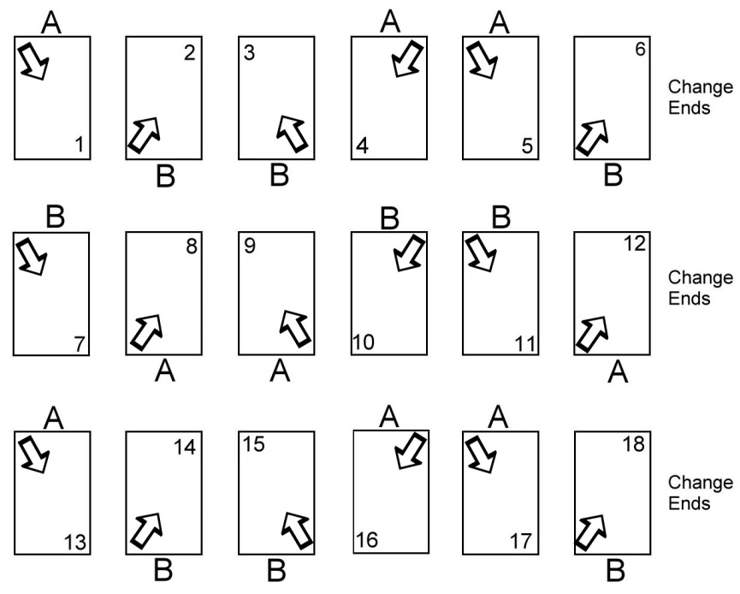
BDTA CONTACTS

PRESIDENT:

VICE PRESIDENT: Allison Miller, 0408 332 929
gaamm@bigpond.com

SECRETARY: Sue Walkerden, 0425 857 844
bdtasec@gmail.com

TREASURER: Christopher Spencer, 0422 440 638
faultlesstennis@icloud.com

SCORE SECRETARY: Barry Palmer, 0409 006 164
illowra2@hotmail.com

DRAWS:

PENNANT COORDINATOR: Vacant

CLUB & COURT DIRECTORY

BEACONHILLS (PAK): Melway Ref: 317 A4
Courts: 10 Synthetic
Beaconhills College Valley Campus, Toomuk Valley Road, Pakenham
Juniors: Quentin Fitzsimmons, 0449 922 661, quentin.fitzsimmons@beaconhills.vic.edu.au

BEACONSFIELD: Melway Ref: 111 J10
Courts: 4 Porous & 5 Synthetic
Recreation Reserve, Emerald Road, Beaconsfield
Juniors: Mark Gelderbloem, 0411 495 251, beaconsfieldjtc@gmail.com

BERWICK: Melway Ref: 111 F6 9796 1698
Courts: 3 Hardcourt & 4 Synthetic
Arch Brown Reserve, Buchanan Road, Berwick
Outside Venue: Pakenham Regional Tennis Centre (see below)
Juniors: Allison Miller, 0408 332 929, gaamm@bigpond.com

CLYDE: Melway Ref: 134 K8 5998 9008
Courts: 6 Hardcourt
Recreation Reserve, Pattersons Road, Clyde
Juniors: Brandon Neale, 0427 399 703, brandon.neale@hotmail.com
Vaughan Smith, 0429 140 076, smithvs@bigpond.com

COCKATOO: Melway Ref: 311 F6
Courts: 4 Synthetic
Recreation Reserve, McBride Street, Cockatoo
Juniors: Judy Knight, 0402 244 982, craig.judy@optusnet.com.au

CRANBOURNE Melway Ref: 134 E7 5995 2866
Courts: 2 Hardcourt & 10 Synthetic
Casey Fields Tennis Centre, Berwick – Cranbourne Road, Cranbourne East
Outside Venue. Grant Street, Cranbourne (see below)
Juniors: Paul Kleverlaan, 0417 741 166, paul@courtcoverage.com.au
Ben Goltz, 0407 846 007, ben@courtcoverage.com.au

DEVON MEADOWS: Melway Ref: 138 D5 5998 2302
Courts: 2 Hardcourt & 4 Synthetic
Glover Recreation Reserve, Browns Road, Devon Meadows
Juniors: Monique Fielding, 0434 611 448, dm.tenniscoaching@gmail.com

FOUNTAIN GATE: Melway Ref: 110 B4 9796 6137
Courts: 6 Synthetic
Raven Crescent, Narre Warren
Juniors: Peter Jedrys, 0405 109 861, pjedrys.oracletennis@gmail.com

GLOUCESTER: Melway Ref: 111 D9
Courts: 4 Hardcourt
St Margaret’s School, Gloucester Avenue, Berwick
Juniors: Allison Miller, 0408 332 929, allison@set4tennis.com.au

GRANT STREET: Melway Ref: 133 J6 5996 6759
Courts: 6 Porous
Grant Street, Cranbourne (2nd drive on left)
Grant Street may be used as an outside venue by Cranbourne.
Affected clubs will be notified.

HALLAM UNITED: Melway Ref: 91 E11
Courts: 4 Asphalt
Hallam Secondary College, Frawley Road, Hallam
Juniors: Chris Spencer, 0422 440 638, faultlesstennis@icloud.com

All Sunday teams are based at Sandhurst (see below)
HARKAWAY: Melway Ref: 109 C12
Courts: 2 Hardcourt & 2 Synthetic
Dalton Reserve, King Road, Harkaway
Juniors: Alex Hogan, 0430 946 666, alex@acceleratetennis.com.au

NARRE WARREN: Melway Ref: 110 K9 9702 0310
Courts: 12 Synthetic
Casey Tennis Centre, Sweeney Reserve, 70 Melzak Way, Berwick
Juniors: Sheyenne Algama, 0424 967 968, sheyenne.algama@gmail.com

NARRE WARREN NORTH: Melway Ref: 108 G5
Courts: 6 Synthetic
Recreation Ground, A’Beckett Road, Narre Warren North
Juniors: Damien Failla, 0438 254 069, damien.failla@hotmail.com

NARRE WARREN SOUTH: Melway Ref: 130 A1 9703 0754
Courts: 6 Synthetic
School Court, Narre Warren South
Juniors: Sue Walkerden, 0425 857 844, nwstennis@gmail.com

OFFICER: Melway Ref: 214 K3
Courts: 6 Hardcourt
Recreation Reserve, Starling Road, Officer
Outside Venue: Pakenham Regional Tennis Centre (see below)
Juniors: Chris Millidonis, 0404 077 673, aceactivetennis@dcsi.net.au

PAKENHAM: Melway Ref: 317 E7 5941 4732
Courts: 6 Synthetic
Anderson Street, Pakenham
Outside Venue: Pakenham Regional Tennis Centre (see below)
Juniors: Tina Fahey, 0414 938 681, ptfence@tpg.com.au

PAKENHAM REGIONAL TENNIS CENTRE: 5940 8510
Courts: 18 Hardcourt Melway Ref: 317 F11
Webster Way, Pakenham
Juniors: David Price, 0431 514 938, david.price@alignedleisure.com.au

Berwick, Officer and Pakenham may also use the PRTC as an outside venue.
Affected clubs will be notified.

SANDHURST: Melway Ref: 128 C9
Courts: 3
Clubhouse Lane, Sandhurst
Sunday venue for Hallam United

TOORADIN: Melway Ref: 149 K9
Courts: 5 Synthetic
Recreation Reserve, South Gippsland Highway, Tooradin
Enter via Stumblers Lane
Juniors: Giselle de Bartolo, 0412 385 735, giselled_1987@hotmail.com

UPPER BEACONSFIELD: Melway Ref: 210 J11 5944 3071
Courts: 6 Porous &1 Synthetic
Sutherland Park, Stoney Creek Road, Upper Beaconsfield
Juniors: Anton Merry, 0401 009 824, anton@sterlingpumps.com.au

ALTERNATE VENUES

BERWICK, OFFICER & PAKENHAM:
Some home matches may be played at the Pakenham Regional Tennis Centre. Affected clubs will be notified.

CRANBOURNE:
Some home matches may be played at the Grant St, Cranbourne courts. Affected clubs will be notified.

SANDHURST:
This will be the home venue for all Hallam United SUNDAY scetions

NOTES ON THE USE OF OTHER THAN 4 TEAM MEMBERS

It is possible using up to 6 team members for each member to play at least 2 sets. Any more than 6 (in theory up to 12 can play) and the number of sets played drops to 1 for at least 1 team member.

Doubles Only Sections

- The basic 4 player, pairing arrangement (1&2 v 1&2, 3&4 v 3&4, etc.) should be maintained. In an emergency, a team is permitted to field only 3 players. They occupy the top 3 places and #4’s sets are forfeited.
- Only change a player number if you are replacing it with the number of an “extra” team member (5, 6). Do not move 1, 2, 3, or 4 around. The pairing arrangement is only to be changed by replacing a number from 1 to 4 with 5 or 6.
- No one is to play more than 1 set with the same partner.
- Even though in the standard match each player follows his or her opposite number (#1 plays 3 sets against #1 and so on), this does not apply to extra players (#5 does NOT have to play any of his or her sets against #5).
- The sets are in 3 groups of 2 sets. So that play on 2 courts is always possible do not substitute with #5 or #6 any more than once (each) in each of the 3 groups – the reporting system used by BDTA will not permit otherwise.

Some Examples

(4 Players) 5 Players 6 Players
Set 1 (1 & 2) Player 1 & Player 2 Player 1 & Player 2
Set 2 (3 & 4) Player 3 & Player 5 Player 3 & Player 4
Set 3 (1 & 3) Player 1 & Player 3 Player 5 & Player 6
Set 4 (2 & 4) Player 2 & Player 4 Player 2 & Player 4
Set 5 (1 & 4) Player 5 & Player 4 Player 1 & Player 6
Set 6 (2 & 3) Player 2 & Player 3 Player 5 & Player 3

(4 Players) 5 Players 6 Players
Set 1 (1 & 2) Player 1 & Player 2 Player 1 & Player 2
Set 2 (3 & 4) Player 3 & Player 4 Player 3 & Player 4
Set 3 (1 & 3) Player 1 & Player 5 Player 1 & Player 5
Set 4 (2 & 4) Player 2 & Player 4 Player 2 & Player 6
Set 5 (1 & 4) Player 1 & Player 4 Player 1 & Player 4
Set 6 (2 & 3) Player 2 & Player 3 Player 5 & Player 3

The examples above represent legal substitution using 1 or 2 extra players.

The following examples demonstrate substitutions that are not permitted. In Case 1 #5 played with #3 twice. In Case 2, #1 and #2 were illegally swapped in the last 2 sets (probably to avoid #5 playing with #1 twice).

(4 Players) Case 1 Case 2 Case 3
Set 1 (1 & 2) Player 1 & Player 2 | Player 1 & Player 2 | Player 5 & Player 2
Set 2 (3 & 4) Player 3 & Player 5 | Player 3 & Player 4 | Player 3 & Player 5
Set 3 (1 & 3) Player 1 & Player 3 | Player 1 & Player 5 | Player 1 & Player 6
Set 4 (2 & 4) Player 2 & Player 4 | Player 2 & Player 4 | Player 6 & Player 4
Set 5 (1 & 4) Player 1 & Player 4 | Player 2 & Player 5 | Player 1 & Player 4
Set 6 (2 & 3) Player 5 & Player 3 | Player 1 & Player 3 | Player 2 & Player 3

In Case 3, even though #5 and #6 only played once with each of their partners, they restricted the ability to use two courts by being in the same pair of sets so these substitutions would be rejected by the Association’s on-line reporting system.

There are a few illustrations of correct pairing proceedure on the following pages. They are by no means complete but do provide one example for every situation.
Home Doubles Side With 5 Players
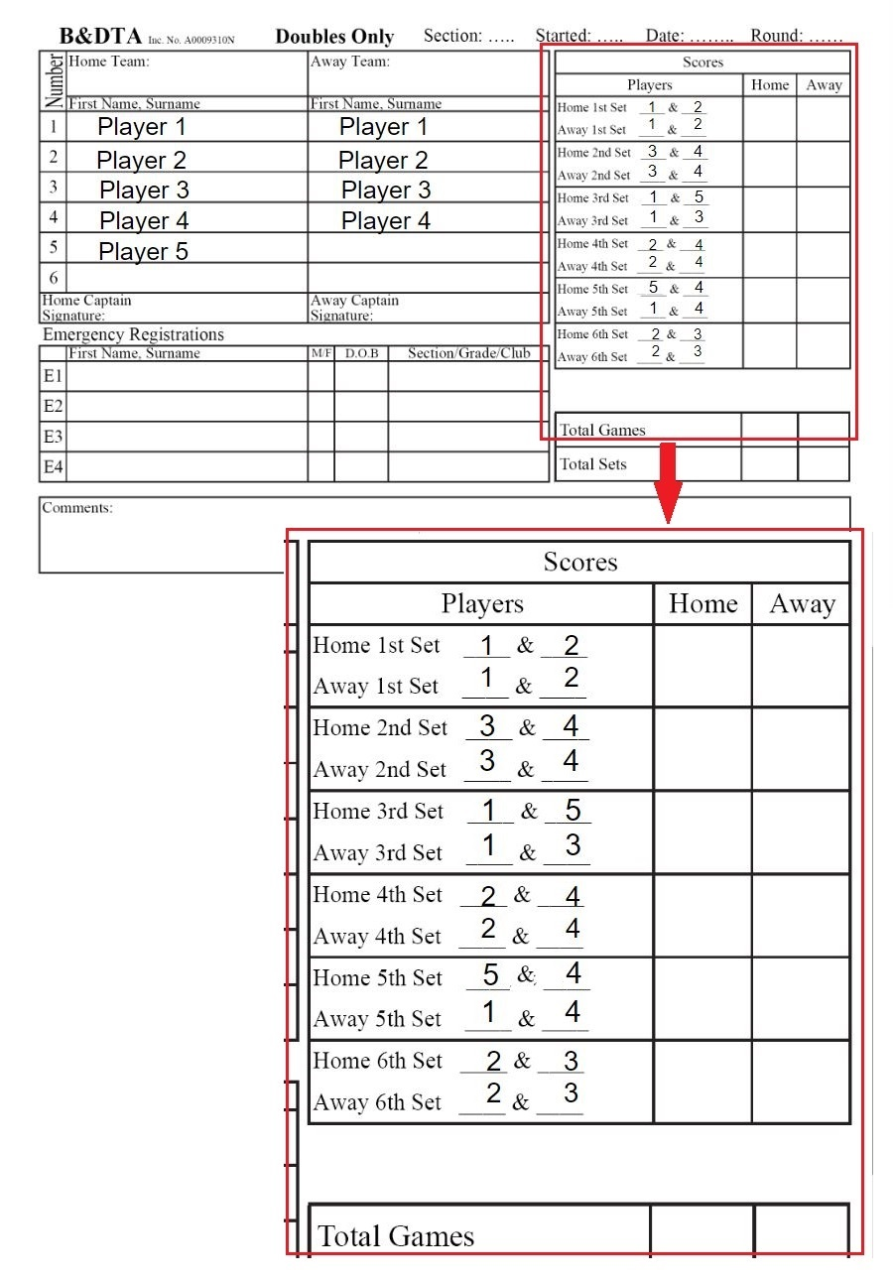
Away Doubles Side With 5 Players.
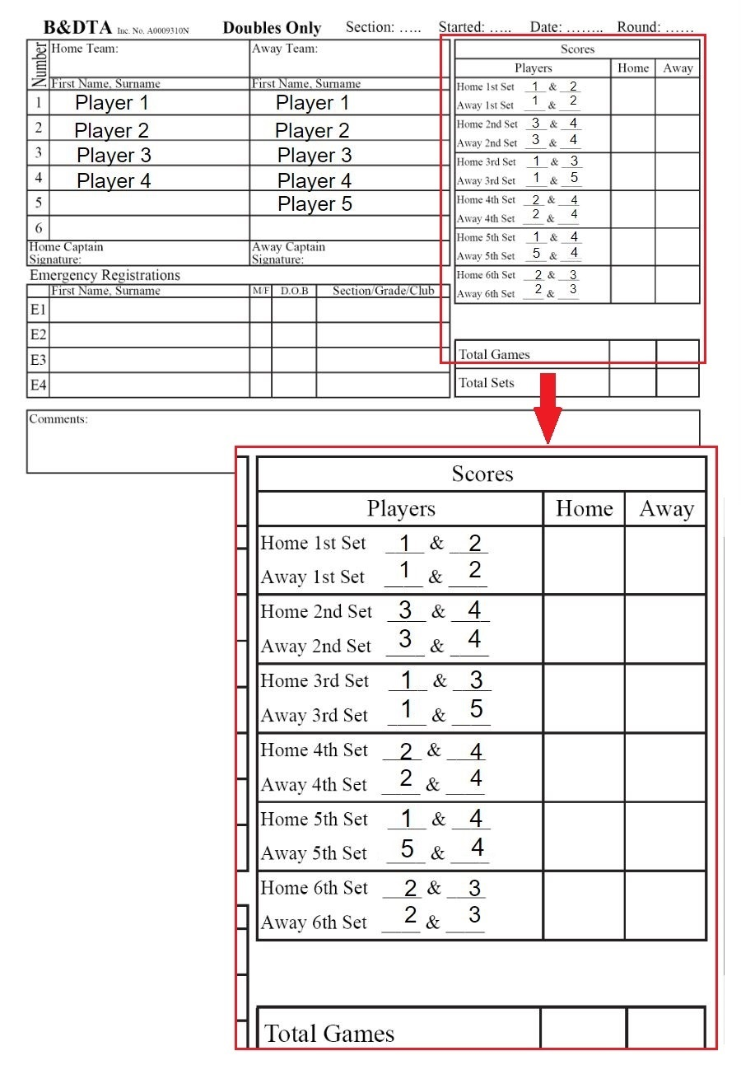

Home Doubles Side With 6 Players
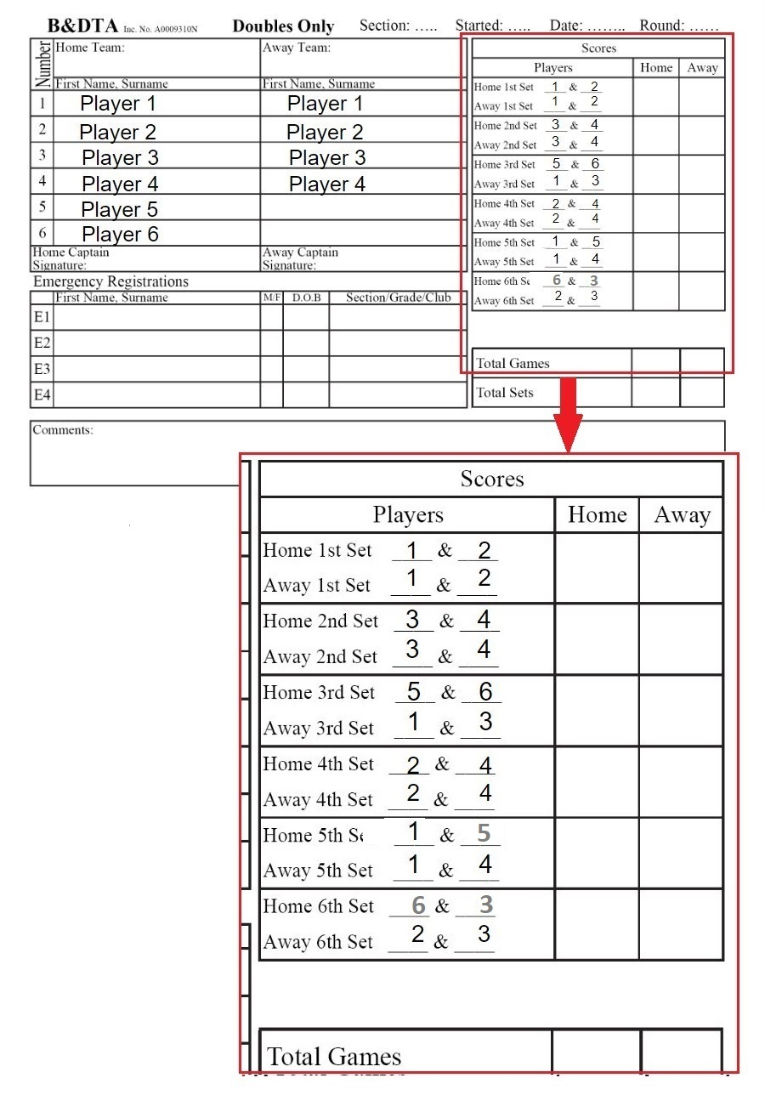

Away Doubles Side With 6 Players.
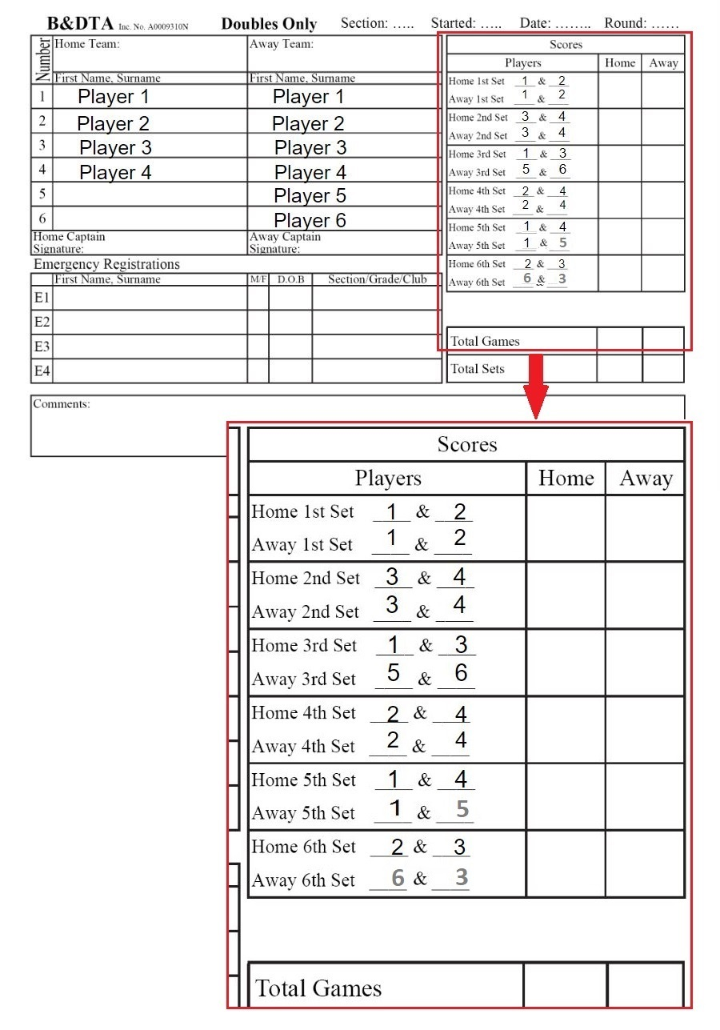

Singles/Doubles Sections

- The first 4 names play singles. They do not have to be the team’s top 4 but they must be in their correct order relative to each other. They do not have to play doubles (Case 2 below).
- Players 5 and 6 play doubles only.
- In the reverse doubles (the 1st pair plays the opposing team’s 2nd pair), no player having already played in the 1st pair is permitted to play in the 2nd pair.
- Doubles pairs may include any of the players.
- Special Case. In an emergency situation, when only 3 play in a team, all 3 may play doubles. In the opening doubles the 1st pair could be Player 1 & Player 2 and in the reverse doubles the 1st pair could be Player 1 & Player 3 (Cases 5 and 6 below). None of the 3 play in the 2nd pair as each of those doubles sets is forfeited.
- If both teams have only 3 players they must occupy the top 3 places. Both sides will forfeit the sets involving #4. When using the system above (to give each player at least 1 doubles set), in the last 2 sets play Pair 1 against Pair 1 (including the 3rd player) and Pair 2 against Pair 2 (Case 7 below).

Some Examples

Case 1 Case 2
Opening Pair 1 Player 5 & Player 1 Player 5 & Player 2
Doubles Pair 2 Player 3 & Player 4 Player 3 & Player 4

Reverse Pair 1 Player 5 & Player 2 Player 5 & Player 2
Doubles Pair 2 Player 3 & Player 4 Player 3 & Player 4

Case 3 Case 4
Opening Pair 1 Player 5 & Player 6 Player 1 & Player 5
Doubles Pair 2 Player 1 & Player 2 Player 2 & Player 6

Reverse Pair 1 Player 5 & Player 6 Player 3 & Player 5
Doubles Pair 2 Player 3 & Player 4 Player 4 & Player 6

The first 4 cases above represent different legal pairs using a 5th and/or a 6th player.

Case 5 Case 6
Opening Pair 1 Player 1 & Player 2 2 & 4, Set Forfeited
Doubles Pair 2 3 & 4, Set Forfeited Player 1 & Player 3

Reverse Pair 1 Player 1 & Player 3 1 & 4, Set Forfeited
Doubles Pair 2 2 & 4, Set Forfeited Player 2 & Player 3

Cases 5 and 6 represent legal pairs when only 3 play in a team and 2 doubles sets are forfeited. All 3 play at least 1 doubles set.

Case 7, Extra Special Situation when both teams have only 3 players.

Home Team Away Team
Opening Pair 1 Player 1 & Player 2 Player 1 & Player 2
Doubles Pair 2 Player 3 Void Set Player 3

Final Pair 1 Player 1 & Player 3 Player 1 & Player 3
Doubles Pair 2 Player 2 Void Set Player 2

This arrangement actually gives all 3 at least 1 doubles set instead of the 3rd player just getting a forfeited set 7 or 8.

Cases 8 and 9 below are examples of illegal pairing arrangements.

Case 8 Case 9
Opening Pair 1 Player 1 & Player 2 Player 1 & Player 5
Doubles Pair 2 Player 5 & Player 4 Player 2 & Player 6

Reverse Pair 1 Player 5 & Player 2 Player 3 & Player 4
Doubles Pair2 Player 3 & Player 4 Player 5 & Player 6

Note that with the exception of Case 7, these examples are arranged as the HOME team would play the doubles. Remember that the away team plays the 2nd pair first in the reverse doubles. If you need an example for an AWAY team, swap the last 2 sets.

As with the Doubles rules, there are a few Illustrations of the correct Singles (Sets) pairing proceedure. There is at least one example of every situation.

Home Singles (Sets) Side With 5 Players.
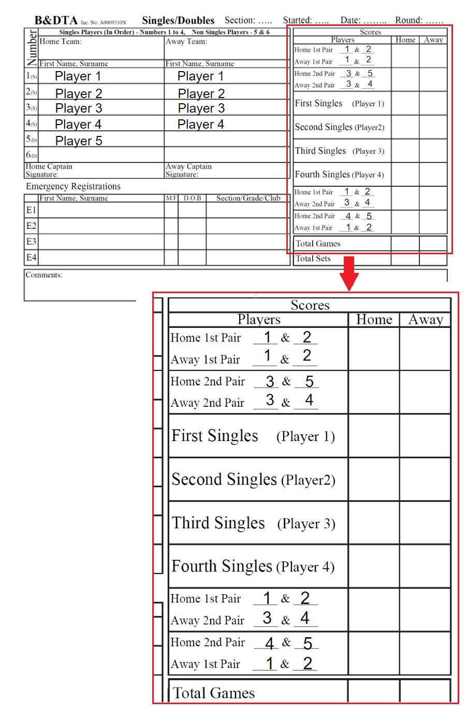
Away Singles (Sets) Side With 5 Players.
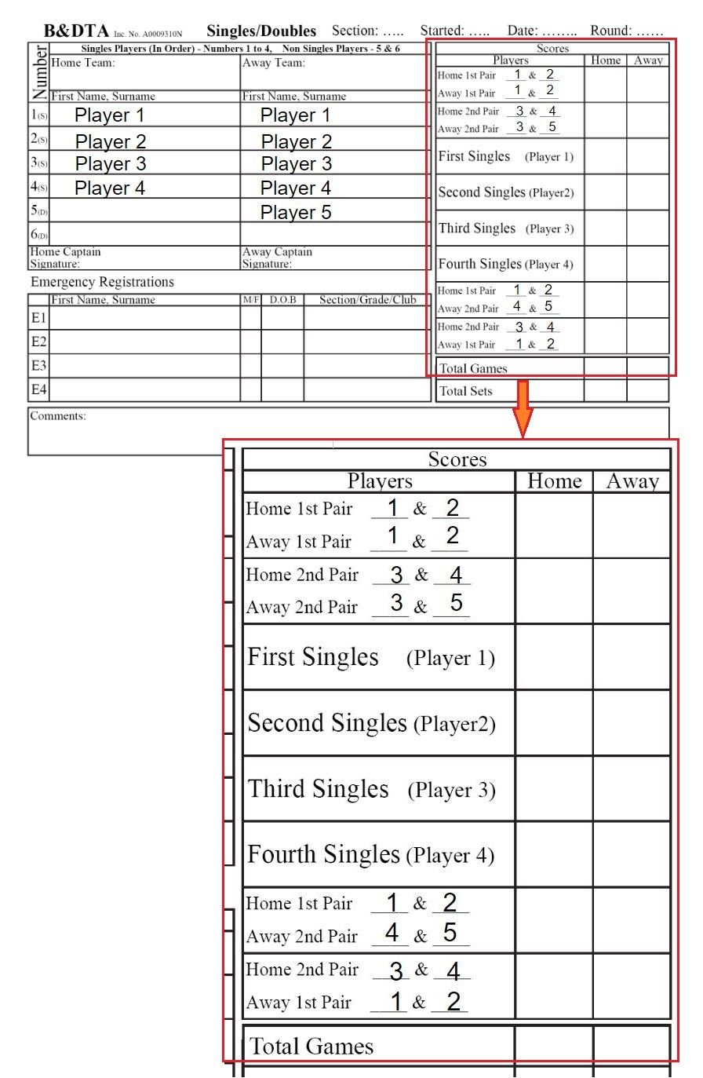
Home Singles (Sets) Side With 6 Players.
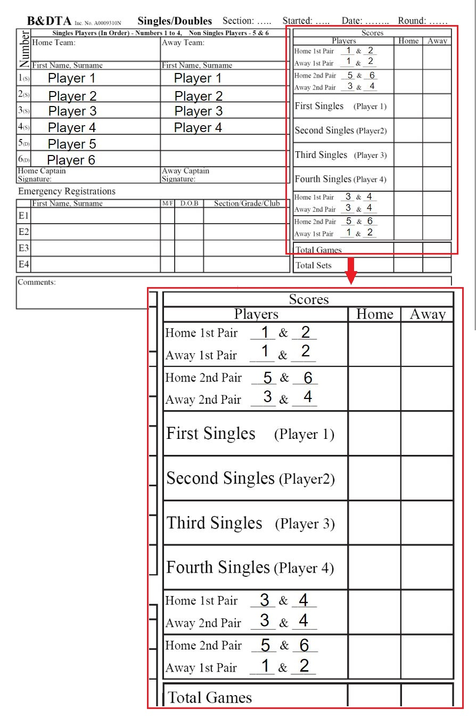
Away Singles (Sets) Side With 6 Players.
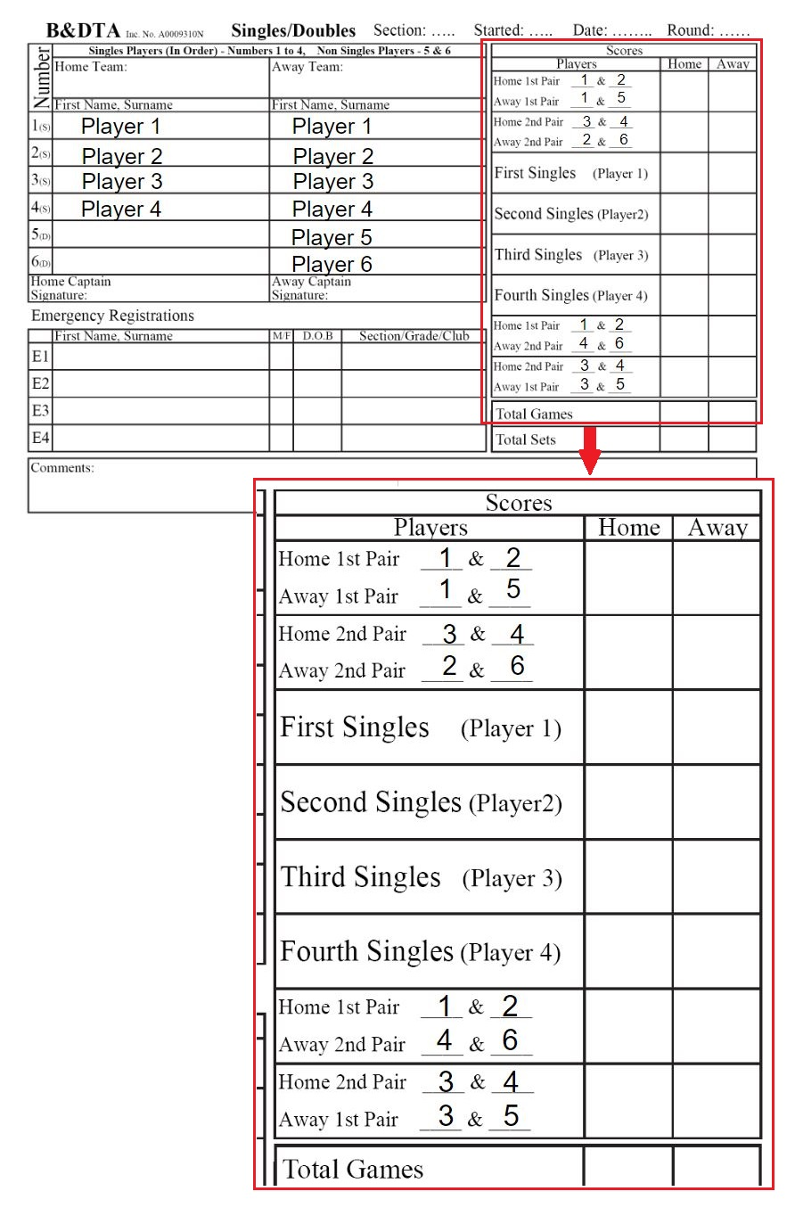
Special Singles Case - Both Sides Only 3 Players
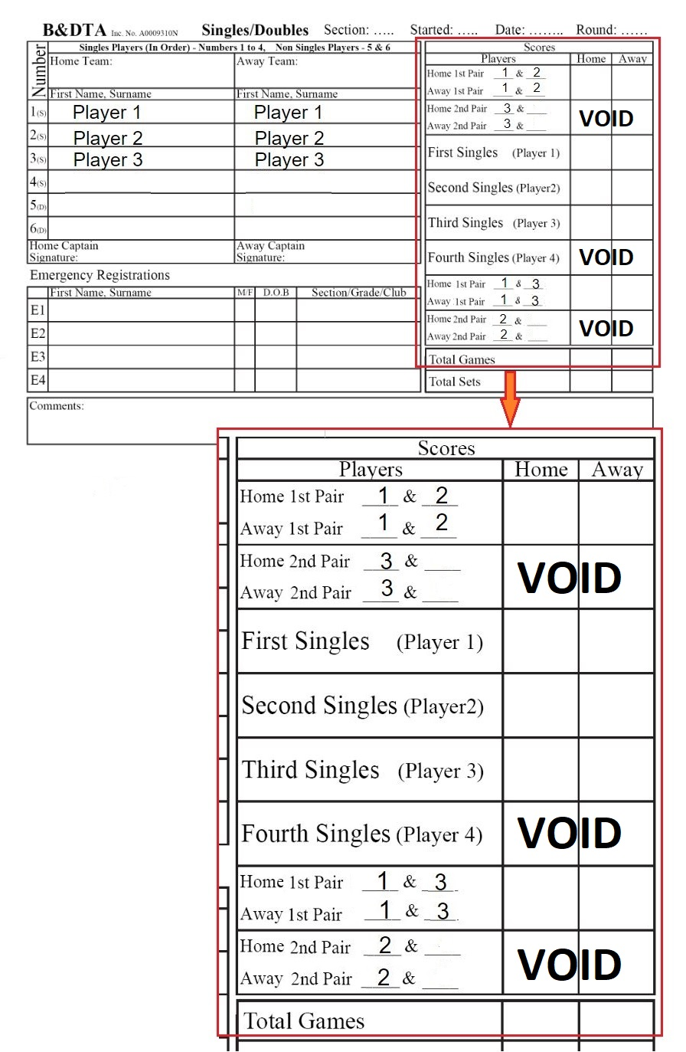

See pages 28-33 for examples of the use of the 5th and 6th players in the doubles sets.
See page 34 for examples of all 3 playing at least 1 doubles set.
See pages 22-7 for examples of the use of the 5th and 6th players.

