
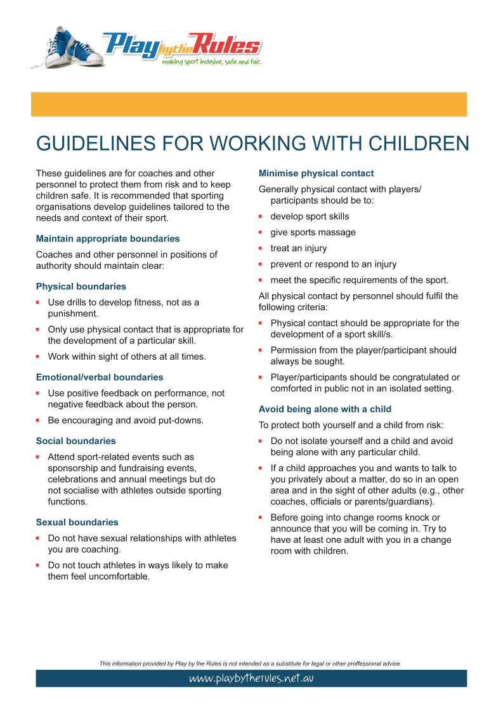
Pakenham Tennis Club – Code of Conduct

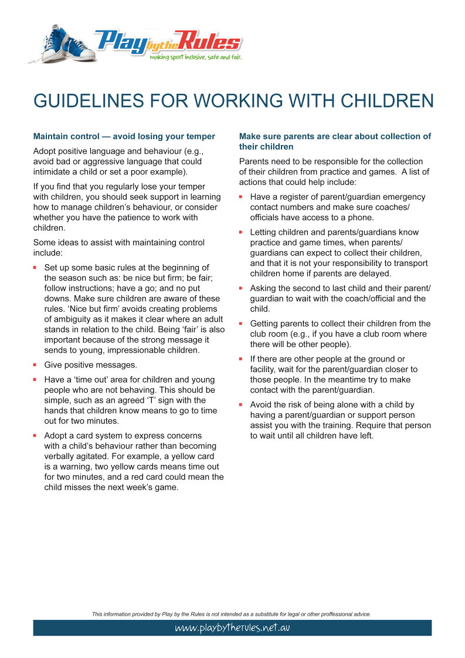

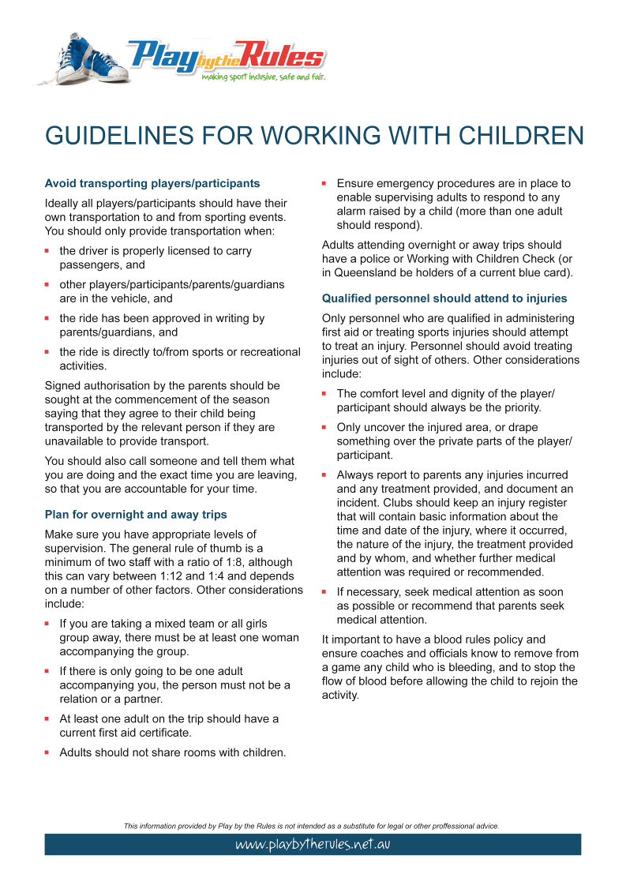

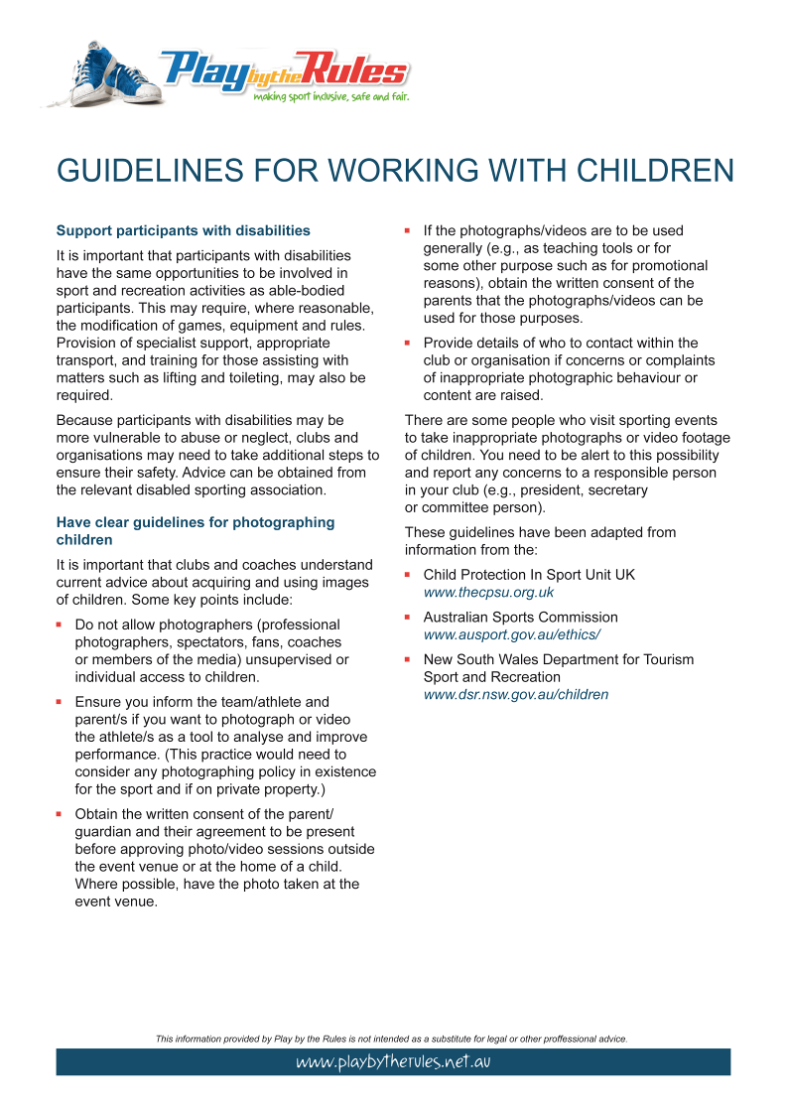


I have been provided with and read the attached “Play by the Rules” Code of Conduct for Pakenham Tennis Club. I agree to abide by this code of conduct and all relevant Child Safety and Member policies.

Print Name:___________________________________________________________

Signature:____________________________________________________________

Date:________________________________________________________________

